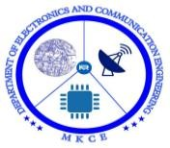

A Minor Project Report on
DEVELOPMENT OF ENERGY METER BASED ON IOT

MINOR PROJECT − I REPORT

Submitted by
VENKAT RAMAN.P (927621BEC238) SUBASH.S (927621BEC215)
SRIVELAN.M (927621BEC209) ARSATH FARVES.T.S (927621BEC301)

BACHELOR OF ENGINEERING
in
DEPARTMENTOF ELECTRONICS AND COMMUNICATION ENGINEERING
M.KUMARASAMY COLLEGE OF ENGINEERING
(Autonomous) KARUR – 639 113
DECEMBER -2022

 | M.KUMARASAMY COLLEGE OF  BONAFIDE CER  Certified that this project repo ENERGY METER BASED ON IO “P.VENKATRAMAN(927621BEC2 C215),M.SRIVELAN(927621BEC2 FARVES(927621BEC301)” who c  under my supervision in the academ  SIGNATURE | ii  ENGINEERING, KARUR TIFICATE  rt “DEVELOPMENT OF  T”is the bonafide work of 38),S.SUBASH(927621BE  09),T.S.ARSATH  arried out the project work ic year 2022-2023.  SIGNATURE | ,
 | Dr.S.PALANIVELLRAJAN, M.E., Ph.D.,  HEAD OF THE DEPARTMENT  Proffessor  Department of Electronics and Communication Engineering, M.Kumarasamy College of Engineering, Thalavapalayam,  Karur-639113 | Dr.K.KARTHIKEYAN, M.Tech., Ph.D.  SUPERVISOR  Assistant Proffessor  Centre of Excellence in PCB, Department of Electronics and Communication Engineering, M.Kumarasamy College of Engineering Thalavapalayam, Karur-639113
This Minor project -I report has been submitted for the 18ECP103LMinor Project –I Review held at M.Kumarasamy College of Engineering, Karur on 2022 - 2023.

PROJECT COORDINATOR

Vision of the Institution

To emerge as a leader among the top institutions in the field of technical education

Mission of the Institution

M1: Produce smart technocrats with empirical knowledge who can surmount the global challenges
M2: Create a diverse, fully engaged, learner-centric campus environment to provide quality education to the students
M3: Maintain mutually beneficial partnerships with our alumni, industry, and Professional associations Vision of the Department

Vision of the Department

To empower the Electronics and Communication Engineering students with emerging technologies, professionalism, innovative research, and social responsibility.

Mission of the Department

M1: Attain the academic excellence through innovative teaching learning process, research areas & laboratories and Consultancy projects.
M2: Inculcate the students in problem solving and lifelong learning ability.
M3: Provide entrepreneurial skills and leadership qualities.
M4: Render the technical knowledge and skills of faculty members.

Program Educational Objectives (PEOs):
- PEO1:Core Competence: Graduates will have a successful career in academia or industry associate with Electronics and Communication Engineering.
- PEO2:Professionalism: Graduates will provide feasible solutions for the challenging problems throug comprehensive research and innovation in the allied areas of Electronics and Communication Engineering.
- PEO3:Lifelong Learning: Graduates will contribute to the social needs lifelong learning, practicing professional ethics and leadership quality through

PROGRAM OUTCOMES(PO'S)
- PO1: Engineering knowledge: Apply the knowledge of mathematics, science, engineering fundamentals, and an engineering specialization to the solution of complex engineering problems
- PO2: Problem analysis: Identify, formulate, review research literature, and analyze complex engineering problems reaching substantiated conclusions using first principles of mathematics, natural sciences, and engineering sciences
- PO3: Design/development of solutions: Design solutions for complex engineering problems and design system components or processes that meet the specified needs with appropriate consideration for the public health and safety, and the cultural, societal, and environmental considerations
- PO4: Conduct investigations of complex problems: Use research- based knowledge and research methods including design of experiments, analysis and interpretation of data, and synthesis of the information to provide valid conclusions
- PO5: Modern tool usage: Create, select, and apply appropriate techniques, resources, and modern engineering and IT tools including prediction and modeling to complex engineering activities with an understanding of the limitations

- PO6: The engineer and society: Apply reasoning informed by the contextual knowledge to assess societal, health, safety, legal and cultural issues and the consequent responsibilities relevant to the professional engineering practice
- PO7: Environment and sustainability:Understand the impact of the professional engineering solutions in societal and environmental contexts, and demonstrate the knowledge of, and need for sustainable development.
- PO8: Ethics :Apply ethical principles and commit to professional ethics and responsibilities and norms of the engineering practice
- PO9: Individual and team work: Function effectively as an individual, and as a member or leader in diverse teams, and in multidisciplinary settings
- PO10: Communication: Communicate effectively on complex engineering activities with the engineering community and with society at large, such as, being able to comprehend and write effective reports and design documentation, make effective presentations, and give and receive clear instructions
- PO11: Project management and finance: Demonstrate knowledge and understanding of the engineering and management principles and apply these to one’s own work, as a member and leader in a team, to manage projects and in multidisciplinary environments
- PO12: Life-long learning: Recognize the need for, and have the preparation and ability to engage in independent and life-long learning in the broadest context of technological change.

PROGRAM SPECIFIC OUTCOMES(PSO'S)

- PSO1: Applying knowledge in various areas, like Electronics, Communications, Signal processing, VLSI, Embedded systems etc., in the design and implementation of Engineering application.
- PSO2: Able to solve complex problems in Electronics and Communication Engineering with analytical and managerial skills either independently or in team using latest hardware and software tools to fulfil the industrial expectations.

MAPPING OF PROJECT WITH POs AND PSO

Abstract | Matching with POs , PSOs
Keywords | PO1,PO2,PO3,PO4,PO5,PO6,PO7,PO8, PO9,PO10,PO11,PO12.  PSO1,PSO2.

ABSTRACT

During the ongoing time period the need of power i.e., electricity is growing exponentially due to the rapid usage of various technologies present around us. Due to this it has been a matter of worry for the developing and developedcountries for need of rapid power outages. Solution for this was inferred as buyers and individuals to monitor their daily usage in their respective places. The project emphasizes on Smart Metering to ensure a cleaner and efficient transmission of power depending upon one’s use and to provide a sustainable development. The meters used since the starting of era don’t provide enough data for the buyer to be aware of the usage and what to or how to monitor the usage. Smart Meter helps thebuyers to monitor them time to time usage and to remotely access their respective loads from anywhere. This project helps in obtaining a newer form of approach to the buyers to help them reduce the cost of usage of power and to help in sustainable development. In addition, we have implemented an IoT system to monitor the use of each load so that the user can track daily energy consumption with the appropriate load.

KEYWORDS: Smart meter, IOT based monitoring, power usage monitoring, smart controlling.

LIST OF CONTENTS

CHAPTER  NO. |  | TITLE | PAGE  NO
1. | INTRODUCTION |  | 1
 | 1.1 | MOTIVATION | 1
 | 1.2 | SCOPE OF STUDY | 2
 | 1.3 | POWER CONSUMPTION | 2
 | 1.4 | BACKGROUND | 3
2. | EXISTING SYSTEM |  | 5
 | 2.1 | LITERATURE REVIEW | 6
3. | PROPOSED SYSTEM |  | 8
 | 3.1 | AIM | 8
 | 3.2 | OBJECTIVES | 8
 | 3.3 | METHODOLOGY | 8
 | 3.4 | CURRENT SENSOR | 10
 | 3.5 | VOLTAGE SENSOR | 10
 | 3.6 | ESP32 CONTROLLER | 11
 | 3.7 | RELAY MODULE | 12
 | 3.8 | LCD DISPLAY | 13
 | 3.9 | I2C MODULE | 13
 | 3.10 | ARDUINO | 14
 | 3.11 | BLYNK APPLICATION | 15
4 | SOFTWARE IMPLEMENTATION |  | 17
 | 4.1 | CODING FOR IOT ON ARDUINO | 17

5. | HARDWARE IMPLEMENTATION |  | 20
 | 5.1 | HARDWARE WORKING | 20
 | 5.2 | PROPOSED SYSTEM IN IDEAL STATE | 21
6. | RESULT AND DISCUSSION |  | 23
 | 6.1 | PROPOSED SYSTEM WHEN LOAD CONNECTED | 23
7. | CONCLUSION |  | 26
8. | REFERENCES |  | 27

LIST OF FIGURES

FIGURE NO. | TITLE | PAGE NO.
3.1 | BLOCK DIAGRAM | 9
3.2 | CURRENT SENSOR | 10
3.3 | VOLTAGE SENSOR | 11
3.4 | ESP32 CONTROLLER | 12
3.5 | RELAY MODULE | 12
3.6 | LCD DISPLAY | 13
3.7 | I2C MODULE | 14
3.8 | ARDUINO SKETCH | 15
3.9 | BLYNK APPLICATION | 16
4.1 | ARDUINO CODING | 17
4.2 | ARDUINO CODING | 18
4.3 | ARDUINO CODING | 18
4.4 | ARDUINO CODING | 19
5.1 | IDEAL STATE VALUE | 21
5.2 | RESULT OF IDEAL STATE | 22
5.3 | RESULT OF IDEAL STATE IN BLYNK | 22
6.1 | FINAL OUTPUT ON LCD | 23
6.2 | FINAL OUTPUT ON APP | 24

CHAPTER 1 INTRODUCTION
Electricity supply in the first phase of household technology is only reliant
on traditional energy meters. These meters are crucial for determining each household's energy use. With developments in technology, the usage of these meters has slowly decreased as fast adjustments have been made to address the issues that emerge with regular meters. When inhabitants are oblivious of their everyday actions, a huge problem occurs. The monthly answer provided to customers is insufficient since consumers will be unaware of how much energy they spend. Smart Meters were designed and improved to address the issues with standard electric meters. Consumers will receive power warnings based on hourly power use, thanks to the utilization of Smart Meter data. The primary purpose of smart meters is to cut down on domestic power usage. Consumer behavior may be studied and evaluated with its expanding market attention. To enhance user behavior, power usage patterns can be simplified. With the installation of smart meters, the power market may be reorganized, saving both energy and carbon dioxide emissions. Only if consumers have a positive experience with these metres can their dependability and reliability be demonstrated. Consumer usage time can be reduced as Smart Meters is connected to online payments.

MOTIVATION
The chance of lowering consumption utilizing the latest Smart Meter data prompted to do this research activity will reduce energy prices. Traditional metros waste a lot of electricity on human energy. With household power usage measured monthly by conventional meters, electrical providers must examine new advances that will benefit both consumers and themselves. The research, however, chooses to make attempts to replace the electric meter in various households by lowering the obstacles erected by consumers. Electricity use

varies daily based on habits and is greatly influenced by customer behavior. Consumers are ignorant of how much consumption is created every hour and at anytime interval per day when using standard meters, since usage is not mentioned. Consumer apprehension might also be misled since most people know relatively little about Smart Meters and how they are installed. Finally, this research is recommended to include encouraging change and worrisome learning in the market.

SCOPE OF STUDY

The energy usage per hour collected from the energy source is the subject of this thesis function. These ad hoc values assist energy resources and users in determining their hourly reported energy usage. In reality, customer behaviour may be tracked and the information can be used to enhance customer experience, particularly when it is linked to a fluctuating price. This role bridges the gap between customers and electrical services, allowing them to interact successfully through cost-cutting techniques. To rectify misunderstandings, consumers must be informed about the measures. Standard data from sixteen groups of households were used in the sample research. The many alterations to usage have been clearly known and defined. Research can also assist consumers in thinking more critically about how they utilise their power. In addition, everyday patterns for an entire day are evaluated hour by hour. Future savings can be achieved by employing speculative models and mitigation approaches to choose when and what material to utilise. All of the following features are available through an IoT application on their mobile phone. From a distant location, a Blynk user may simply monitor the entire process of power consumption by diverse loads.

POWER CONSUMPTION

Energy consumption refers to the overall quantity of energy utilised in each residence. The amount of energy consumed is a significant influence in the provision of electricity. People must be cautious about conserving energy so

that it can be used in the future. Energy trends have been slightly varied with daily electricity use. These differences can sometimes be created by weather circumstances or people' inefficient use of energy, such as the increased number of electrical equipment in various households and a casual attitude toward their usage, such as not switching off lights or t.v. when not in use. These characteristics might suggest a large influence on the end consumer. Because energy firms offer power, most individuals are unconcerned with energy and its cost savings. With the concept of resources, the relevance of consumption diminishes. Energy resources should play a pivotal role in the development of Advanced Metering technology, allowing individuals to contribute in minimizing energy impacts by becoming more aware of the influence of their current level of consumption.

BACKGROUND

Electricity had only been available to a few group of the rich in the early years. Over time, technological advancements enabled regular people in various regions of the world to have their needs met. Archaeologists have been involved in the genesis of the electric meter. In the early 1870s, telegraphs and arc lights were the most common uses of electricity. In 1879, Thomas Elva Edison invented the electric light, which opened up the electric power industry to the general public. In 1888, Oliver B. Shallenberger debuted his AC amp hour clock. Finally, ongoing advancements in measuring technology bring illumination to many regular people's lives.
Electric meters are electrical devices that can detect and show energy in a form of learning. Since the late 1800s, traditional meters have been in use. For both the generation and distribution of power, they communicate data amongst electronic equipment in a computerized environment. Alumina specimen are used to measure power use in various electric meters. Electric meters today are digital, yet they still have significant restrictions.
The following are among some of the shortcomings of a basic electric meter:
  - Consumers will expect a monthly utility payment; therefore, meters aren't

inherently dependable. • The architecture of some devices supports the measuring process, which is why they are referred to as electromechanical meters. • A significant number of testers are required for meter readings. • Checkout process is time-consuming and costly. • It is not possible to establish a new sort of hourly rate with the accompanying meter to urge the consumer. • Metered software applications and supporting network infrastructure are difficult to develop.

Apart from the above-mentioned limitations, there are a few other factors that influence a huge gap between the consumer and the distributor due to the installation of traditional meters.

CHAPTER 2 EXISTING SYSTEM

When it comes to the usage of electrical equipment in the house, human behavior is referred to as consumer behavior. If client usage is high, we may sympathize also with premise that gadget usage is similarly high, implying also that cost is related to the number of times the product is used and the length of time it is used. Customer expectations are critical for energy firms to satisfy. In reality, the majority of customers anticipate receiving a monthly charge. They frequently have no idea whether appliances are energy-efficient or how to effectively monitor their use. These elements have a significant impact on customer behavior. Only by examining how people utilize their power can we gain a greater understanding of human behavior. Consumers should be cautiously influenced when accessing their electronic devices [2].
Grid Computing is a recent advancement in electricity grid technology. In terms of flexibility in the power generating capacity of electrical equipment within the home, contemporary power infrastructure are lacking. Power systems are also growing more vulnerable as the population grows. The demand on the grid increases as the population grows. Smart Grid [31] is a technology that improves grid productivity by remotely regulating and enhancing dependability, balancing the usage of supported communications to provide data (in real time) to customers, providers, and vice versa. In Smart Grids, automatic sensors are employed. These sensors are in charge of receiving measured data from applications, as well as transporting power failures and preventing power cables from overheating. It makes advantage of the surgical function. In reality, the Smart Meter concept arose from the Smart Grid notion. By 2030, a 5% decrease in carbon emissions is predicted yearly as a result of its implementation, which might have a substantial impact on environmental change [31]. Smart Grids are

advocated in several nations for sustainable growth and the building of new grid infrastructure.

2.1 LITERATURE REVIEW
The poll is divided into four sections: socioeconomic concerns, technological concerns, case studies, and predictions. The separation of instances was chosen to collect data for the study in an ordered manner, since we began with a literature study in the early stages of research.
The services offered by the service provider determine the customer satisfaction in the digital economy.
The rating system also mentions features like real-time power monitoring, which allows users to see the consequences of contraction and relaxation electrical objects and calculate the cost accordingly, as well as receiving notifications directly from the utility network. The publication features timely usage patterns for nights and weekends. The poll was carried out in numerous nations and places, with the same results achieved to encourage people to acknowledge authority. Smart Meters are being used to promote the usage of renewable energy through social-tech updates. There is a proposed set of study questions, also including 1) Has been the answer beneficial in energy conservation and behaviour change? 2) What constitutes a successful and good feedback presentation? Scientific guidance on energy-saving tools for the house is available [3]. Low-cost metres, energy efficiency, and fast fraud detection are all advantages of the Smart Metering idea [7].
Communication between meters and household appliances is done in a variety of ways. Communication can be through wire transmitted means, wireless means (communication) and electrical connection from the home appliances to the meters [1].
[8], Smart Meter usage and detection incorporates multiple Smart Meter installations constant monitor and send feedback to the customer. The users of

the smart meters will get electricity without the worry of theft and at the same time carbon offset discharges can also be predicted or sometimes seen.
- , The structure of the SEMS was made into action for production level of Smart integrated load conditions Electrical items. Unit prices, usage and usage costs under diverse real-life conditions i.e., very high, medium and non-peak values are divided. Each energy cost the object used is shown in the image.
- , The value of the Meter in real life in relation to the buyer as well big beneficiaries changed. Functions and advantage of Smart Meters set side by side to the described meter. Researchers were curious hypothesis of questions proposed in this particular research paper. The user should be familiar with the energy used. Hence we infer to have a sustainable development and use the resource carefully.
[10], Usage pathways are studied in both UK and beneficiary buildings, in which present condition and time to time monitoring is done using the technology. Real life presence of smart meters, their usage pathways and their efficiency is studied in detail. Test set are designed for three indoor buildings. The test set contains a component of the device and interface. Scatter diagram are seen in a daily time zone online period during the week, on Sundays, before and after the exchange of material. Analysis is also performed for water heating, opening the middle temperature.
The answer to recommend and validate most common electrical apparatus. [36], complete quarter of a minute sit-by-50m data analysis was used to detect a number of specific applications such as the desired response strength, abnormal loads behavior and error detection.

CHAPTER 3 PROPOSED SYSTEM

AIM
The purpose of this system is to go through the energy consumption to help make a green and clean environment and further to help in sustainable development.

OBJECTIVES
- To monitor power consumption of load in order that we are able to control the high-power consumption load.
- To provide remote access for the user so he/ she will be able to monitor or observe power consumption from anywhere.

METHODOLOGY
In proposed system we are going to attend monitor current and voltage across each load in order that we are able to observe power consumption in every hour or every minute or whenever we would like. this may provide a facility of controlling the electrical bill by monitoring overall power consumption of a house. we are going to connect the present sensor and voltage sensor to the system for monitoring power consumption of every load in order that we are able to observe which load in an exceedingly household is consuming more power. Current sensor are going to be connected asynchronous and voltage sensor will connect in parallel with the load. so equal current and equal voltage will move to each load. The used sensor (current) fetches the time to time condition and the readings from AC source and the other sensor (voltage) will fetch the voltage readings of the same source. the worth of current and voltage are displayed on LCD display furthermore as IOT

dashboard. We will use Blynk application for providing program so one can easily monitor the ability and switch off the high-power consuming load if that load isn't in use. the subsequent figure shows the diagram of proposed system.
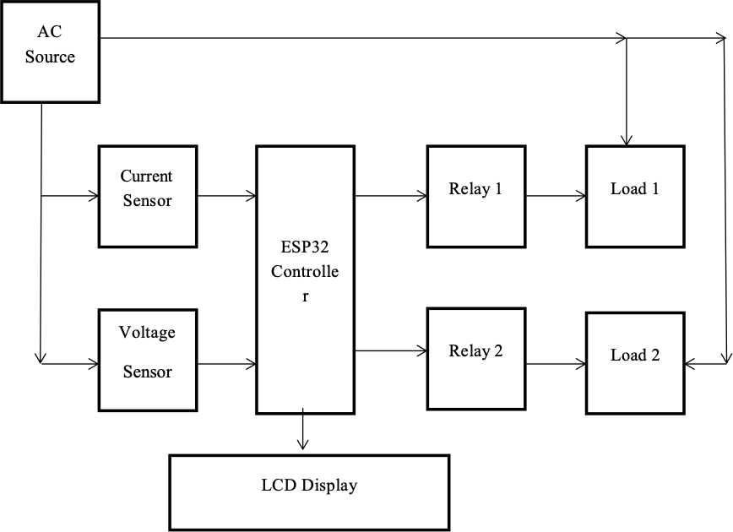

Fig.3.1 Block Diagram

The block diagram consists of AC source from which we get power for loads, one current sensor, a voltage sensor, ESP32 microcontroller, two relay modules and two different loads. The current sensor and voltage sensor will give the power value which will be given to the controller to turn on or turn off the loads. The load can be operated from remote distance using IOT Blynk application. We are not using any kind of physical switch to turn on or turn off the loads hence loads can be operated through IOT dashboard. Two relays are used to connect the respective load with controller. These relays will help to control overloading situation and prevent load from the damage. In the system, current sensors are used to measure the incoming and outgoing current flowing through energy meter. The relay module is used to control loads. ESp32 controller will give the control signals to relay for operation.

CURRENT SENSOR

It's a gadget that detects current and converts it to a measured output voltage proportionate to the current flowing along a specific path. Sensors come in a variety of shapes and sizes, every single one is designed for a specified condition and purpouse. A current sensing resistor is the most common of these sensors. It's a current-to-voltage converter in which the current is linearly converted to voltage by putting a resistor into the current channel. There are various sensors which can have distinct features for number of applications, the technology employed by the present sensor is significant either open or closed loop.
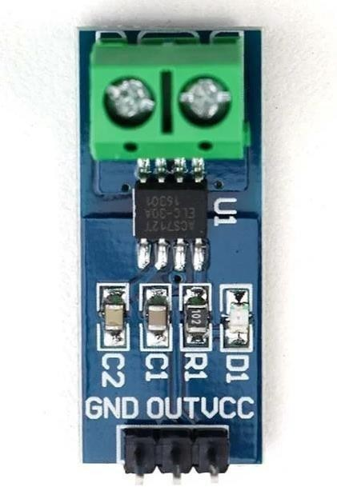
Fig. 3.2. Current sensor

VOLTAGE SENSOR

A voltage sensor is a gadget available that can help to detect or sense or measure the present voltage in the system. The sensor can detect the kind of voltage present (may it be AC or DC voltage).The input for the sensor is the voltage present and the possible outputs are analogue voltage signal, current signal, or audible signal are the sensor's output. The ZMPT101B AC Voltage

Sensor is true to be employed. The sensor present is the best gadget for measuring the voltage (may it be AC or DC voltage) with the help on an open- source platform like Arduino. Engineers deal directly with measurements in many electrical projects, which have some basic needs like high galvanic isolation, wide range, high precision, and good consistency. Within a 250V AC voltage range, modules is also monitored and so the analogue output modified. It's fresh new, high-quality, and efficient.

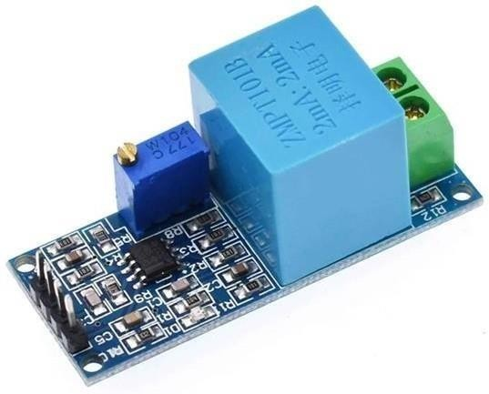

Fig.3.3. Voltage sensor

ESP32 CONTROLLER

It is a sequence of less cost, less power arrangement with bluetooth and and Wi-Fi combined together. This gadget gives scope of use in both of the technology namely bluetooth and Wi-Fi that helps in better connectivity and transmission of data within a small arrangement of components.

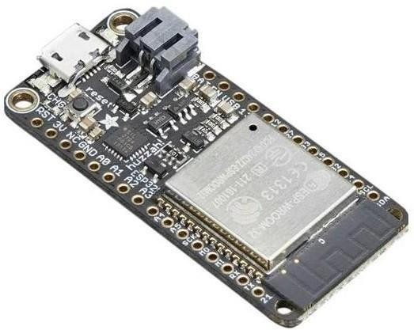

Fig.3.4. ESP32 Controller

RELAY MODULE

A current carrying coil of an insulated wire wrapped around a piece of iron is an electromagnet. A power relay module is an electrical switch which is operated with the help of an electromagnet , which is activated by a low power signal generated by a microcontroller..
When the current passes, the electromagnet completes or breaks the electrical circuit. It is a flame sensor Relay module that can detect the flame of wavelength at 760nm to 1100nm range of the light source.
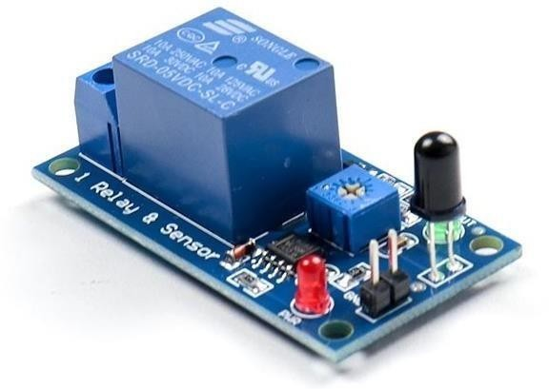
Fig.3.5. Relay Module

LCD DISPLAY

LCD is a display that operates in the first mode. The appliance connected is continuously monitored by Arduino UNO and is displayed upon the LCD present. The load increases, a message about power usage is delivered to the system and necessary data is seen on the LCD. LCD- Liquid Crystal Display is a straight 2-D display which takes support, help of the light-modulating features of liquid crystals bought together with polarizers. Liquid crystals don’t have their own light instead a backlight is needed for them to enlighten and glow.
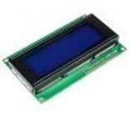
Fig.3.6. LCD Display

I2C MODULE

I2C Module has a factory present PCF8574 I2C chip which changes I2C serial data to parallel data to display. This gadget is present with a factory enabled I2C address which is 0*27 / 0*3F to figure out which configuration we have got we can check it through the black I2C adaptor which is on the downside of the gadget. If A0, A1, A2 named pads present then the default gadget configuration we’ve is 0*3F and if there aren’t any named pads then the configuration received is 0*27. This helps in adjusting the contrast and brightness of the LCD that is used.

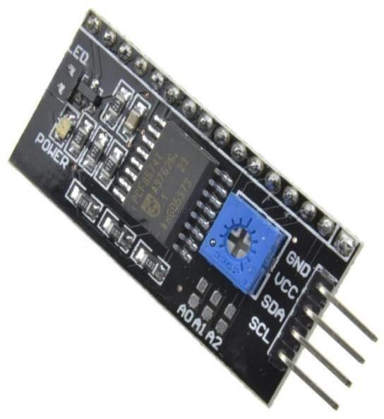
Fig.3. 7. I2C module

ARDUINO

It is a software that enables us to write a code according to our needs and later enables the feature to upload the code to our hardware. It establishes connection between the hardware (ardino) to upload the code and then execute it. Codes that are executed by this software are called sketches. These codes are encrypted in text editor and are saved as file name.ino. The bottom most right cornered part helps in displaying the board that we configured and the the serial used port. The buttons on the toolbar helps us to cross check the encrypted data, save the encrypted data and to display the previously stored encrypted data.

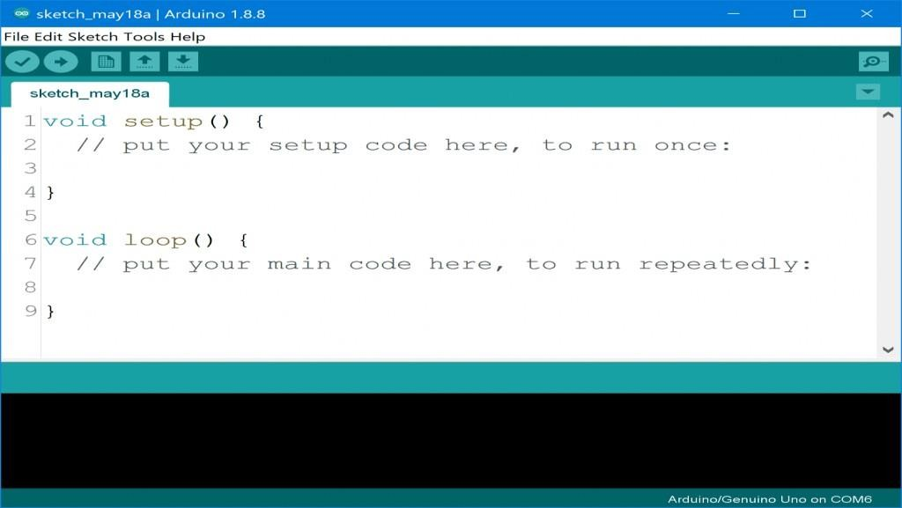

Fig3.8. Arduino Sketch

BLYNK APPLICATION
Blynk is used for IOT (Internet of Things). It is used to monitor data on the made system through dashboard, save data and memorize it.
Components of the application are-

Interface – Shows data to be executed in forms that we customize according to our vision and need.
Blynk Server – It establishes connection between the hardware and the device used for dashboard.
Blynk Libraries – It stores all data required for hardware execution on the IOT dashboard.

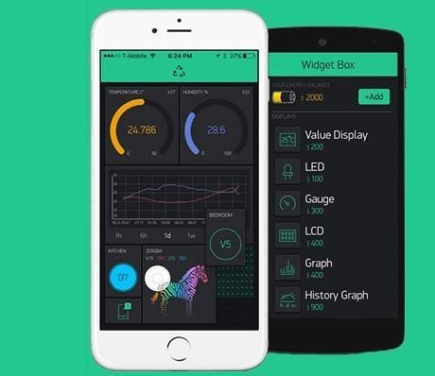

Fig.3.9. Blynk Application

CHAPTER 4

SOFTWARE IMPLEMENTATION

4.1. CODING FOR IOT ON AURDINO

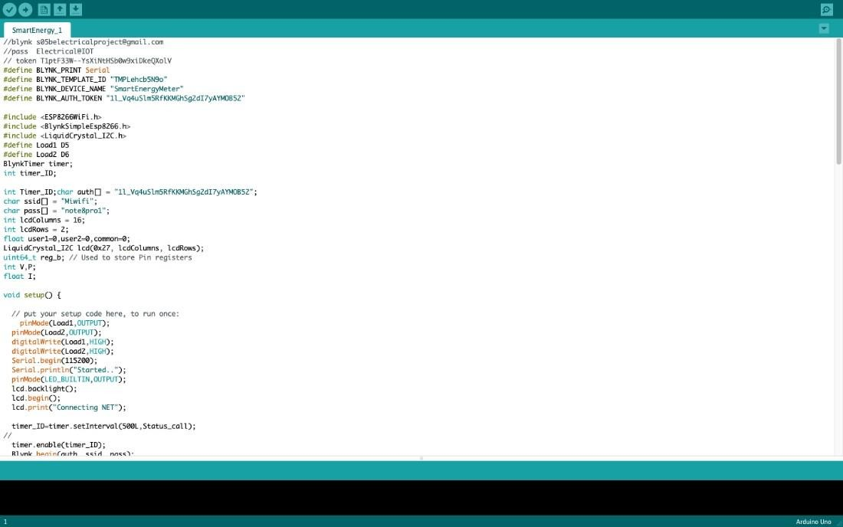
Fig.41. Coding In Arduino

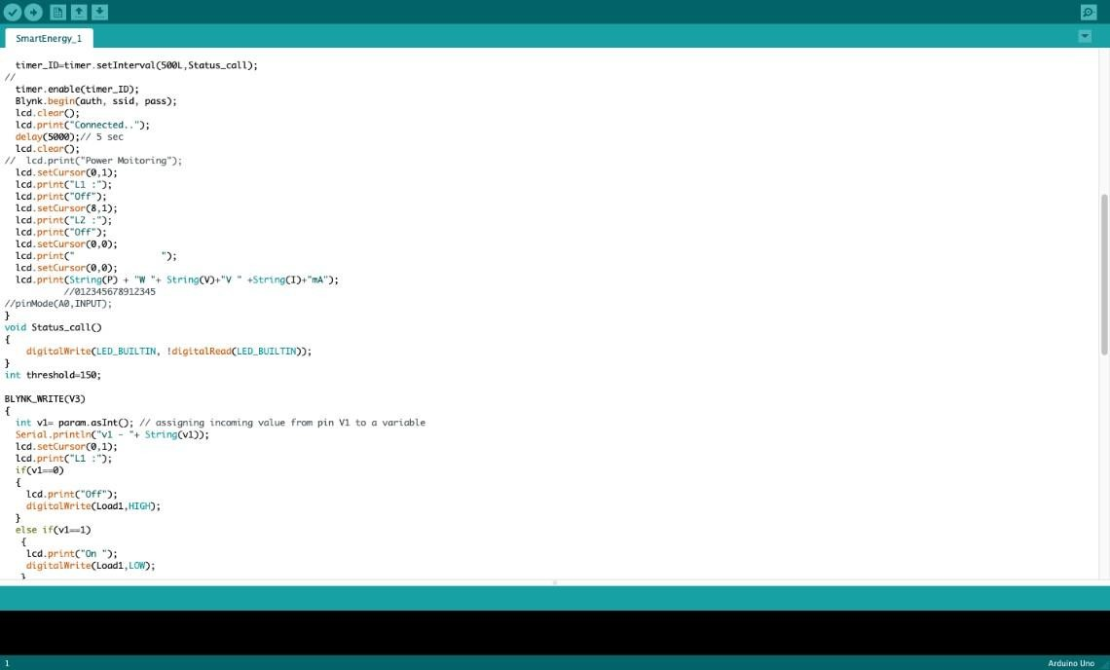
Fig. 4.2. Coding In Arduino

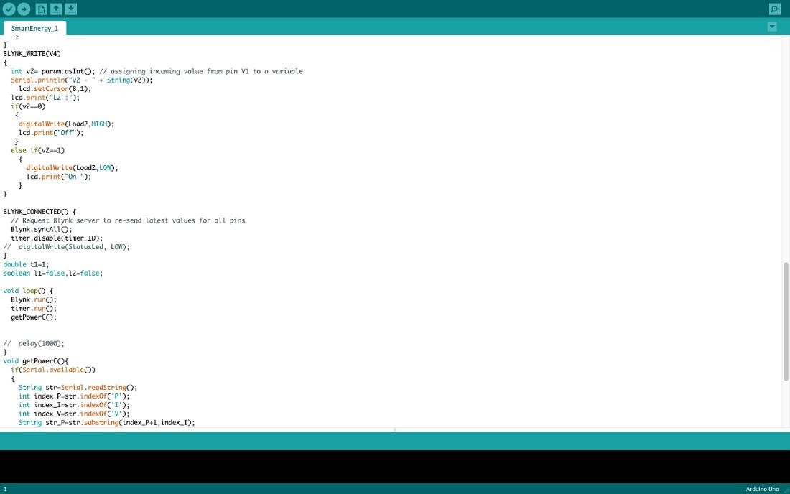
Fig. 4.3. Coding In Arduino

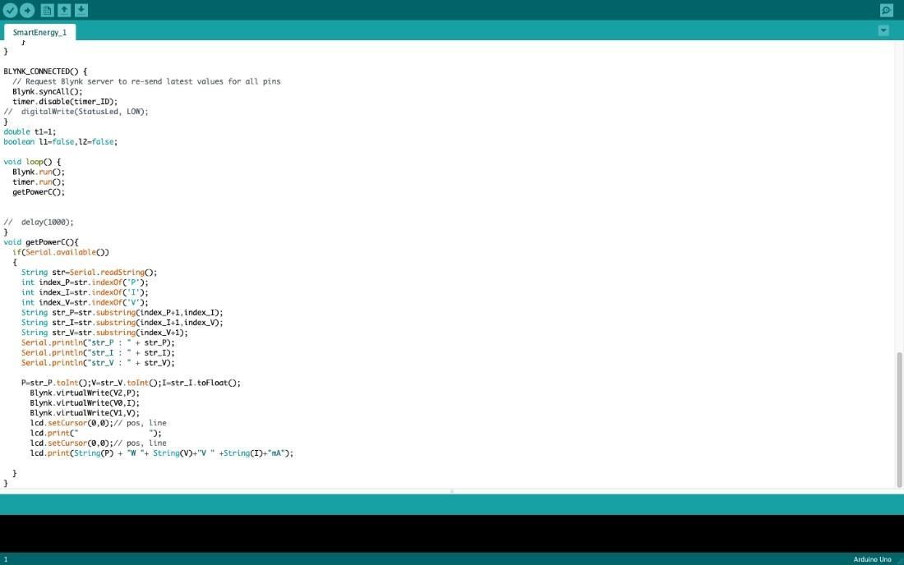

Fig.4.4. Coding In Arduino

CHAPTER 5

HARDWARE IMPLEMENTATION AND RESULTS

5.1 HARDWARE WORKING

An AC power source is connected to the load for operation. We have connected current sensor in series and voltage sensor in parallel with the loads. The value of current and voltage is detected by the sensors and given to the controller used. Controller will read the sensor values and then displayed them on LCD display as well as IOT dashboard. For displaying data on LCD we have used I2C module to convert serial data coming from controller into parallel data for LCD display. We have used ESp32 controller which has inbuilt Wi-Fi facility to connect to the internet. Using this facility controller will send data to the IOT dashboard. To connect with IOT dashboard we have used an application called Blynk app. This app will give us an user interface to monitor and control the loads. The controller will also operate the relay device which will further use to turn ON or turn OFF the loads as we are not using any physical button to on or off the loads. Relays are connected to the controller at pin number D3 and D4. The purpose of relays is to provide path for the current to reach the load. These relays will be ON or OFF by the IOT application when the overload occurs. One end of relays is connected to the controller and other end is connected to the load. When controller allows relay turn ON then only current reaches to the load. Power value will be indicating on LCD display which is connected to the controller via I2C module which converts serial data from controller to parallel data for LCD display. I2C module has 4pins which are connected to the digital pins of controller. SCL and SDA pins of module are connected at D1 and D2 pins respectively. Rest 2 pins are ground and supply pins which are connected to ground and supply pins of controller.

5.2. PROPOSED SYSTEM IN IDEAL STATE
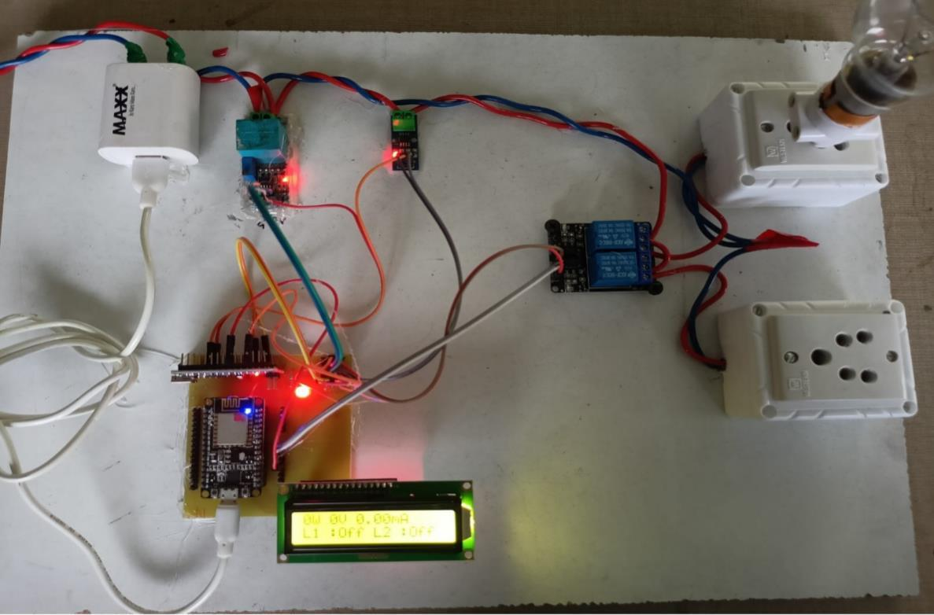

Fig.5.1. Ideal state value

When there is no load connected at the output side or no load is in ON state that means no current or voltage is drawn from the source. As shown in above figure the voltage, current and the power values are zero. As soon as when we connected load at the output the current voltage and power ratings consumed by the load will be displayed on LCD.
These values are can also be monitored on IOT dashboard using Blynk application. The Blynk application provide user interface to the user for monitoring and controlling purpose. Using this application, we can monitor and control the load from the remote distance.

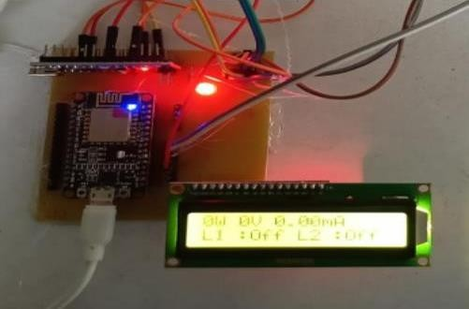

Fig.5.2. Result of Ideal state

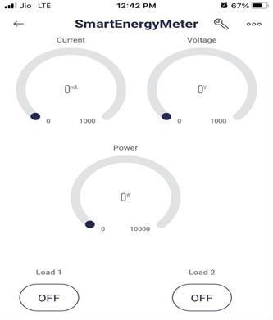

Fig.5.3. Result of Ideal state on Blynk

CHAPTER 6 RESULT AND DISCUSSION

6.1 PROPOSED SYSTEM WHEN LOAD CONNECTED
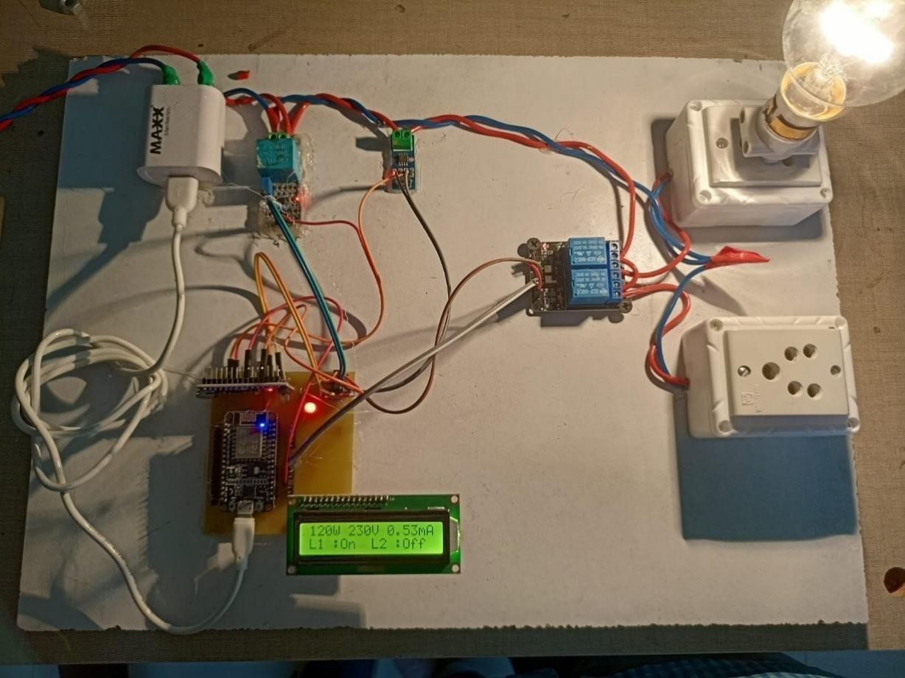
Fig.6.1. Final Output on LCD

In the above figure 6.1 we have connected a bulb on Load 1 for measurement of current and voltage. The results show that the bulb we have used is consuming 0.53mA current and 230V voltage. The power rating of this bulb is displayed on LCD and that is 120W.
We have operated this load from the Blynk application. As soon as we touch the load 1 it will get turn on within a seconds, the LCD display is showing that only load 1 is ON whereas load2 is still off. We can connect any other load like fan, lamp or any other electrical device to load 2 for measuring their electricity consumption.

To switch between the loads, we have used relay module. This relay module will connect the load to the AC source.

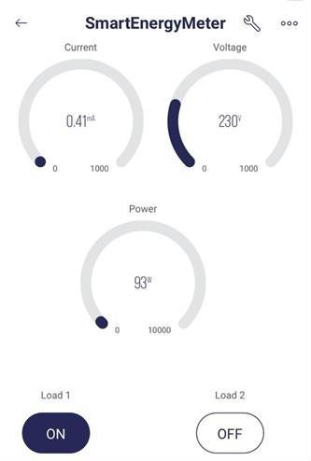
Fig.6.2. Final Output on APP

The IOT dashboard shows in the above result when load is connected to the bulb. The result says that the bulb was consuming 0.41mA current and 230V voltage. The power consumed by this bulb was 93W. the result on LCD display was taken by the different load and for IOT we have connected different bulb. That is why the output of load are different in Blynk application and on LCD display. We can monitor the power consumption of load from any distance with

the help of IOT Blynk application and can turn OFF or turn ON the loads if needed.

CHAPTER 7 CONCLUSION

The proposed system is able to alleviate the suffering of the customer and make users worry about the excessive use of electricity and faulty home appliances. With this program, customers can easily view a complete heartbeat, complete units and total electrical costs. The program is easy to read and reliable. The data stored in the cloud is of great value in the extraction of energy meter data in the future. In a big sense, a power distribution company like DPDC is able to identify the pattern of local use.

CHAPTER 8 REFERENCES

- F. Benzi, N. Anglani, E. Bassi, and L. Frosini, ―Electricity Smart Meters Interfacing the Households,‖ IEEE Transactions on Industrial Electronics, vol. 58, no. 10, Oct. 2011, pp. 4487–4494.
- E. F. Livgard, "Electricity customers' attitudes towards Smart Metering," in IEEE International Symposium on Industrial Electronics (ISIE), July. 2010, pp. 2519-2523.
- Z. Qiu, G. Deconinck , "Smart Meter's feedback and the potential for energy savings in household sector: A survey," in IEEE International Conference on Networking, Sensing and Control (ICNSC), April 2011, pp.281- 286.
- J. M. Bohli, C. Sorge, and O. Ugus, ―A Privacy Model for Smart Metering,‖ in IEEE International Conference on Communications Workshops (ICC), 2010, pp. 1–5.
- M. Weiss, F. Mattern, T. Graml, T. Staake, and E. Fleisch, ―Handy feedback: Connecting Smart Meters with mobile phones,‖ in 8th International Conference on Mobile and Ubiquitous Multimedia, Cambridge, United Kingdom, Nov. 2009.
- L. O. AlAbdulkarim and Z. Lukszo, ―Smart Metering for the future energy systems in the Netherlands,‖ in Fourth International Conference on Critical Infrastructures, 2009, pp. 1–7.
- M. Popa, H. Ciocarlie, A. S. Popa, and M. B. Racz, ―Smart Metering for monitoring domestic utilities,‖ in 14th International Conference on Intelligent Engineering Systems (INES), 2010, pp. 55–60.

- S. Ahmad, ―Smart Metering and home automation solutions for the next decade,‖ in International Conference on Emerging Trends in Networks and Computer Communications (ETNCC), 2011, pp. 200–204.
- J. Stragier, L. Hauttekeete, L. De Marez, "Introducing Smart grids in residential contexts: Consumers' perception of Smart household appliances," in IEEE Conference on Innovative Technologies for an Efficient and Reliable Electricity Supply (CITRES), Sept. 2010, pp.135-142.
- S. David, S. Peter, ―Characterisation of Energy Consumption in Domestic Households,‖ in IET Conference on Renewable Power Generation., Strood., Kent, Sept. 2011, pp. 1-8.

- N. Lu, P. Du, X. Guo and L. G. Frank, ―Smart Meter Data Analysis,‖ in Transmission and Distribution Conference and Exposition (T&D), May. 2012, pp. 1-6.
- D. Ren, H. Li and Y. Ji, "Home energy management system for the residential load control based on the price prediction," in Online Conference on Green Communications, Sept. 2011, pp. 1-6.
- D. Y. R. Nagesh, J. V. V. Krishna and S. S. Tulasiram, ―A Real-Time Architecture for Smart Energy Management,‖ in Innovative Smart Grid Technologies (ISGT), Jan. 2010, pp. 1-4.
- G. Deconinck, B. Delvaux, K. De Craemer, Z. Qiu and R. Belmans,
―Smart Meters from the angles of consumer protection and public service obligations,‖ in Intelligent System Application to Power Systems (ISAP), 2011, pp.1-6.
- T. Choi, K. Ko, S. Park, Y. Jang, Y. Yoon and S. Im, ―Analysis of Energy Savings using Smart Metering System and IHD (In-Home Display),‖ in Transmission and Distribution Conference and Exposition, 2009, pp.1-4.

